ASSIGNMENT SURENDER D, 513119106086

**Create a home automation using 2-3 sensors**

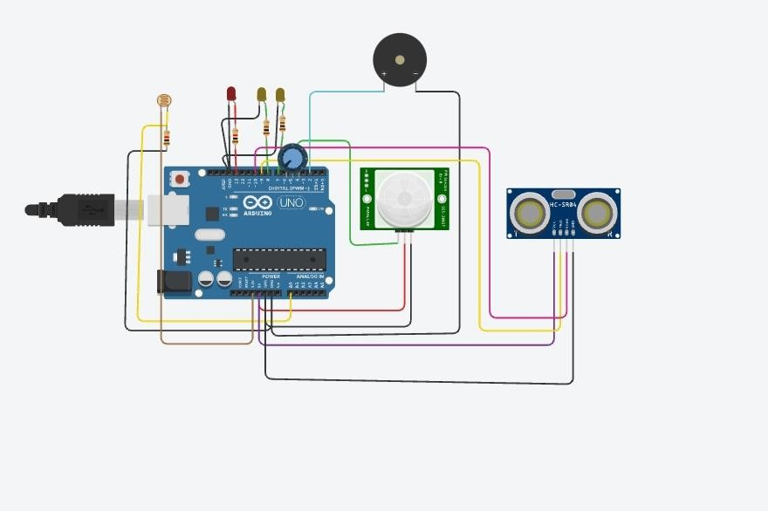

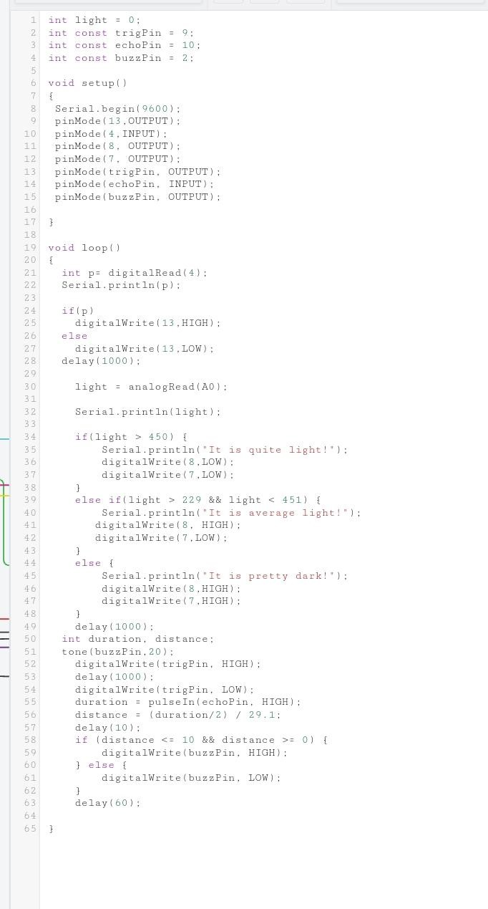

**TINKER CAD LINK:**

https://www.tinkercad.com/things/dhOepXTKMCv-assignment-1/editel?sharecode=obxR-4yE k8OUqW5wC8y0e6Mrbik_mRMbpR0M3pq4BTY